
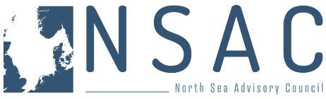
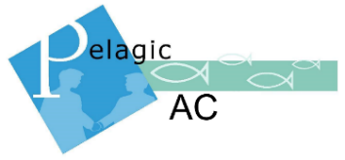
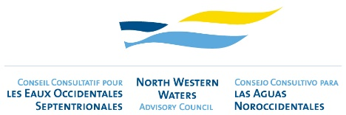
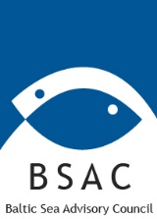
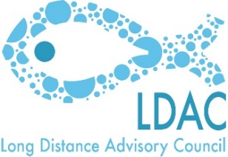
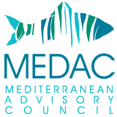


AGENDA
Multi-AC workshop on the revised control regulation
Wednesday 05 February 2025
Albert-Borchette-Centre, AB-4B (RUE FROISSART 36), Brussels

Horizontal Session with remote access (FR, DE, EN, IT, ES, PT)
08:30 – 08:40 | 1 Welcome and introductions – tbc
08:40 – 09:10 | 2 Presentation on the state of play of the implementation of the control regulation – Marta Moren-Abat, DG MARE
09:10 – 10:00 | 3 Topics for discussion  - Clarifying Roles and Responsibilities: Who does what?  - Remote Electronic Monitoring (REM): Define criteria for identifying "high-risk" vessels.  - ACs to provide their views if any  - Specify standardised technical requirements, equipment maintenance needs, and associated costs.  - Establish guidelines on data use, ownership and transmission protocols.  - Clarify accountability in cases of transmission errors versus fisher responsibility.  - Address monitoring approaches for vessels outside the mandatory CCTV scope as well as third-country vessels fishing in EU waters.  - Electronic Logbook Submission: Establish requirements for completing and submitting electronic logbooks to ensure accuracy and compliance.  - Short introduction from COMM  - Harmonization of Control and Enforcement: Standardize control activities, points system, and sanctions across Member States for consistent enforcement.  - ACs to provide their views, if any
10:00 – 10:15 | Coffee break
NWWAC/PelAC/NSAC/BSAC session – in person only (EN-FR-ES)
10:15 – 12:30 | 1 Remote electronic monitoring  - Consider EU standards versus third-country requirements and in particular UK-Scotland.
10:15 – 12:30 | 2 Vessel Monitoring Systems (VMS) for Small-Scale Vessels  - COMM to provide brief introduction and reminding obligations under CR  - Feedback from ACs, if any  - Examine costs and explore affordable alternatives for small-scale operators.  - Clarify accountability in cases of transmission errors versus fisher responsibility.  - Propose a joint Member State (MS) system for streamlined VMS implementation.
10:15 – 12:30 | 3 Weighing Procedures  - Commission to provide a brief introduction  - Feedback from ACs, if any  - Clarify and standardize weighing procedures across fisheries to maintain consistency.  - Feasibility of sampling procedures for the weighing at landing of sorted fishery products that have already been weighed on board
10:15 – 12:30 | 4 Review the practicality of the current Margin of Tolerance requirements  - COMM to provide a brief reminder of the revised CR on Article 14 (MoT)  - ACs to provide their views if any
10:15 – 12:30 | 5 Review the current requirements for a port to be listed as a Designated Port to avail of a derogation to the Margin or Tolerance rules.  ACs to provide their views, if any
10:15 – 12:30 | 6 Monitoring Engine Power:  - Define technical specifications, equipment and maintenance needs and associated costs.  - Define criteria for identifying "high-risk" vessels.  - Provide clear guidance on implementation and compliance.  ACs to provide their views, if any
10:15 – 12:30 | 7 Use and opportunities of EMFAF and other funding opportunities if any.
LDAC session (EN)
12:30 – 13:00 | 1 Prior notification of landings in third countries (list of designated ports).  - ACs to provide their views, if any
12:30 – 13:00 | 2 Fishing vessels other than catching vessels.  - ACs to provide their views, if any
12:30 – 13:00 | 3 Transshipments outside EU waters and in non EU ports  - ACs to provide their views, if any
12:30 – 13:00 | 4 Derogation of 20pc of Margin of Tolerance (MoT) for EU tropical tuna purse seine fleets on third country fishing ports.  - ACs to provide their views, if any

